23 September 2024 postcard

No electric kettle or coffee dispenser in the hotel, but when you order tea there, they bring you a heavy ceramic pot holding 2 to 3 cups full of hot water, so I threw my teabag in with good results. I got three cups of very good tea.

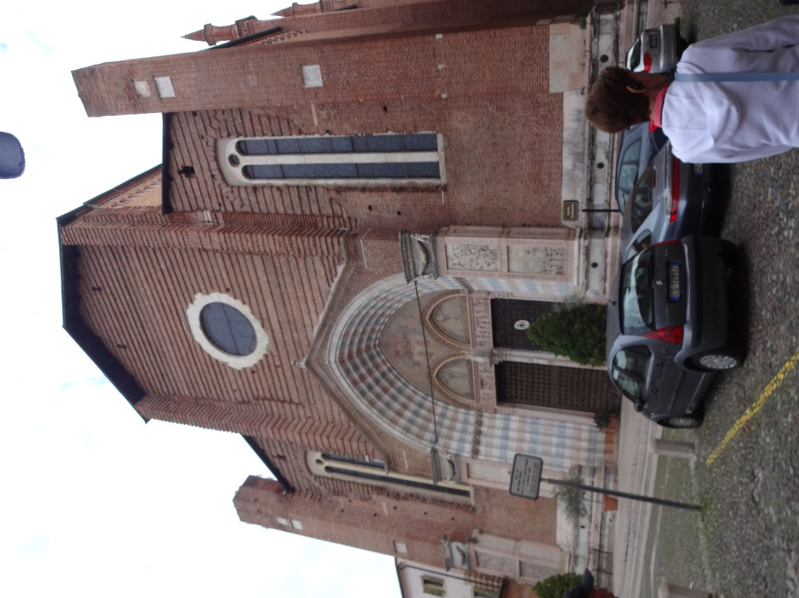Got a leisurely start on our walking tour of Verona which occupies a horseshoe bend of the River Adige. Here's the church of Santa Anastasia, immediately outside our hotel. It's supposed to be gorgeous inside, but I never got a chance to go in. It was closed when we went by the first time and I never got back to it.

We started with a stroll along the river to admire the ruins, visible across the way, of the city's original Roman theater—only a half circle. The full-circle arena was located outside the Roman walls but inside the larger Medieval ones. Several centuries ago, a bad earthquake brought down its outer ring of arches, but the remainder is far better preserved than most Roman amphitheaters. They still hold a whole open-air opera season there every year.

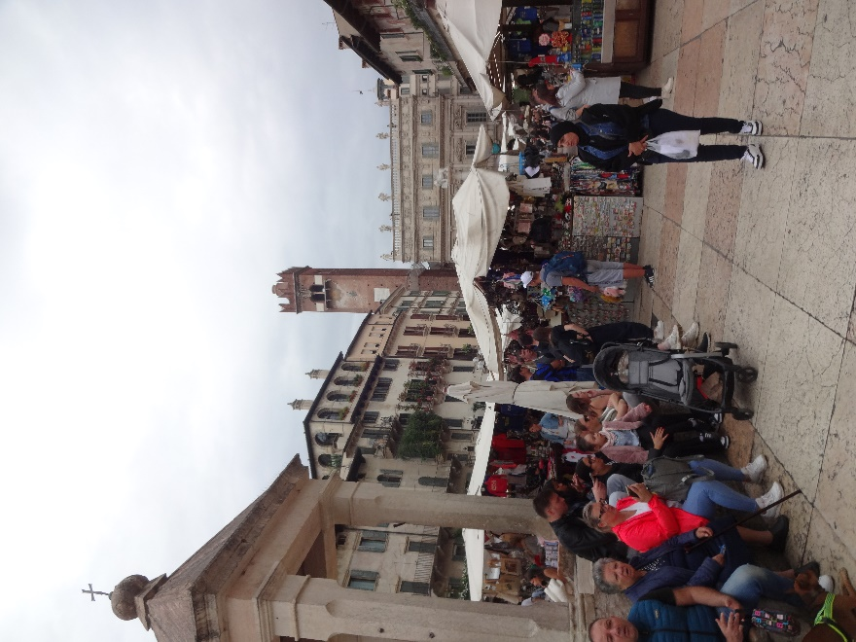Here's the bustling little market we walked through to get to the amphitheater. It was mostly clothes, accessories, and souvenirs. Very little food.

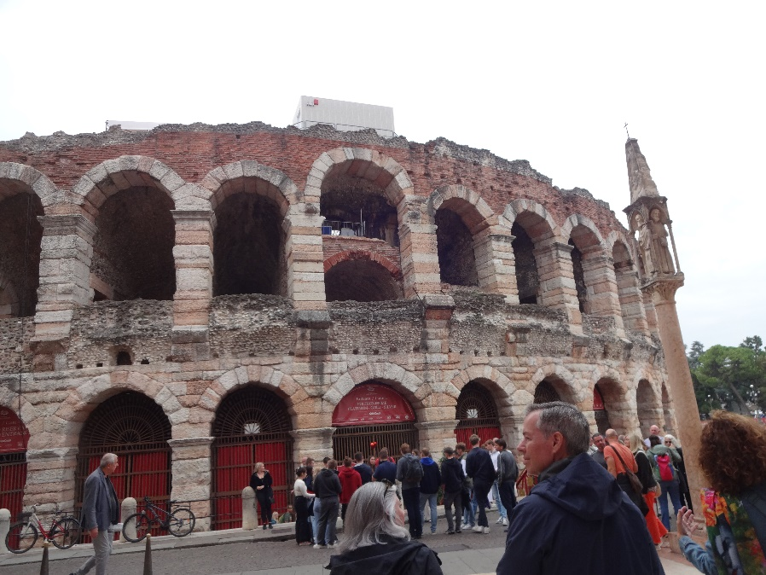

We didn't have time to go inside the amphitheater. Among the other sites we visited were Romeo's house and Juliet's house. Of course neither really was the house even of plausible historical models for the characters, but people are really eager to visit them. You can even visit Juliet's tomb!

In fact, Juliet's house, and the balcony in particular, have developed a cult following. Thousands of people every year write letters to Juliet asking advice, especially about romantic involvements and a corps of volunteers (speakers of many languages, since the letters come from all over the world) actually answers all of them, with handwritten advice! I'm not sure just who in this situation is crazier.

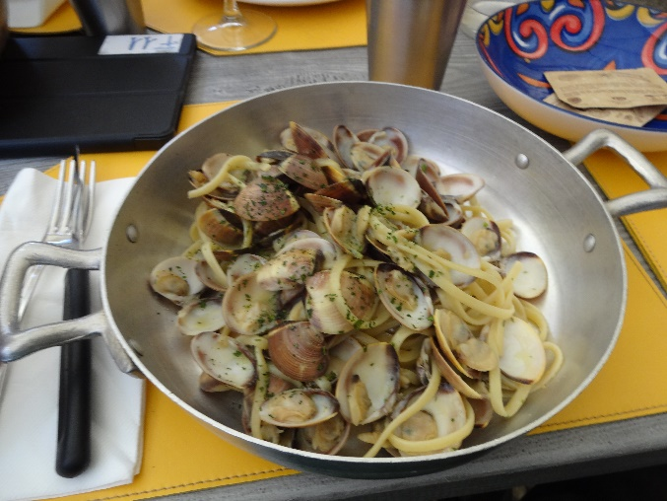The people of Verona, are very proud of all their city has to offer tourists in the way of Roman, Medieval, Renaissance, and modern art and architecture and are understandably annoyed that so much of their tourism is drawn by Romeo and Juliet!

Here's the lovely bowl of linguine with white clam sauce that I had for lunch on our way back to the hotel.

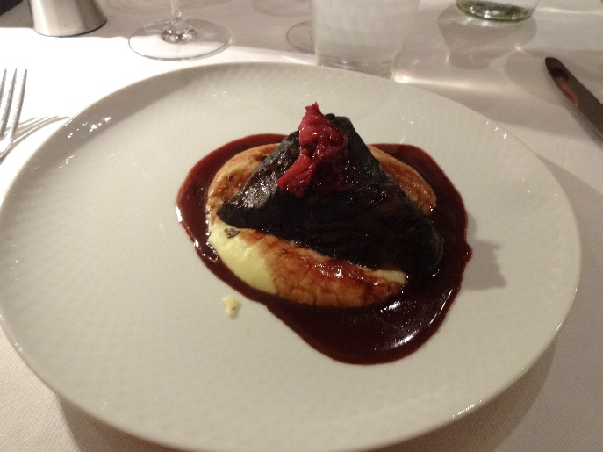We had dinner in a local restaurant selected by Tauck. David had (among other things) a nice pasta with rabbit ragout, and I had a scrumptious beef cheek braised in Barolo wine, served on a bed of mashed potatoes, and surrounded by a cherry sauce.

Between the main course and dessert, we got to go down the restaurant's subbasement to admire the Roman ruins it was built over.